EFS (Elastic File System)

To set up Amazon EFS (Elastic File System) and mount it on your EC2 instance, follow these steps:
Step 1: Create an EFS File System
- Log in to AWS Console:
- Open the Amazon EFS Console.
- Create File System:
- In the EFS dashboard, click Create file system.
- Choose the VPC where your EC2 instance is located.
- Select the Availability Zones (AZs) where you want the file system to be available.
- For Performance Mode, select General Purpose (recommended for most workloads).
- For Throughput Mode, select Bursting or Provisioned, depending on your needs.
- Click Create to create the file system.
After creating the file system, you'll be able to see the File System ID and Mount Targets.

Step 2: Configure Security Groups
- Modify Security Groups:
- Ensure the security group of your EC2 instance allows inbound traffic on port 2049 (the NFS port).
- Modify the security group of the EFS mount target to allow traffic from the EC2 security group on port 2049 (NFS).
- Allow NFS Traffic:
- Go to EC2 Dashboard > Security Groups and modify the security groups associated with the EC2 and EFS mount target to allow TCP traffic on port 2049.

Step 3: Install NFS Utilities on EC2 Instance
You need to install NFS client utilities on your EC2 instance to mount the EFS file system.
- For Amazon Linux 2:
sudo yum install -y nfs-utils
- For Ubuntu:
sudo apt-get update
sudo apt-get install -y nfs-common

Step 4: Mount the EFS File System
- Find the EFS DNS Name:
- In the EFS Console, under Mount Targets, find the DNS name of your EFS file system. It will look something like this: fs-xxxxxx.efs.us-west-2.amazonaws.com.
- Create a Mount Directory:
- On your EC2 instance, create a directory where the EFS will be mounted:
sudo mkdir /mnt/efs
- Mount the EFS:
- Use the mount command with the EFS DNS name to mount it to your EC2 instance:
sudo mount -t nfs4 fs-xxxxxx.efs.us-west-2.amazonaws.com:/ /mnt/efs
Replace fs-xxxxxx.efs.us-west-2.amazonaws.com with your EFS DNS name.
- Verify the Mount:
- You can verify that the file system is mounted by running:
df -h
You should see the EFS file system listed as mounted on /mnt/efs.

Step 5: Make the EFS Mount Persistent (Optional)
To ensure that the EFS file system is automatically mounted after a reboot, add it to the /etc/fstab file.
- Edit /etc/fstab:
- Open the /etc/fstab file with a text editor:
sudo nano /etc/fstab
- Add the Mount Entry:
- Add the following line to the end of the file:
fs-xxxxxx.efs.us-west-2.amazonaws.com:/ /mnt/efs nfs4 defaults,_netdev 0 0
Replace fs-xxxxxx.efs.us-west-2.amazonaws.com with your EFS DNS name.
- Test /etc/fstab:
- After modifying /etc/fstab, you can unmount the file system and mount everything listed in /etc/fstab:
sudo umount /mnt/efs
sudo mount -a
- Verify the Mount:
- Run the following command to ensure everything is mounted correctly:
df -h

Step 6: (Optional) Set Permissions on EFS
Ensure that the correct permissions are set for the EC2 instance to access the EFS file system.
- Change Ownership and Permissions:
- Set the correct owner and permissions for the mounted directory:
sudo chown ec2-user:ec2-user /mnt/efs
sudo chmod 755 /mnt/efs

Step 7: Test EFS
- Create a Test File:
- Create a test file to verify that the EFS is working:
echo "Hello from EFS!" > /mnt/efs/testfile.txt
- Check the File:
- List the contents of the mounted directory:
ls /mnt/efs
You should see the testfile.txt file you just created.

Conclusion
To summarize, the basic steps to set up Amazon EFS and mount it on an EC2 instance are:
- Create an EFS file system.
- Configure security groups to allow NFS traffic.
- Install NFS utilities on the EC2 instance.
- Mount the EFS file system to the EC2 instance.
- (Optional) Configure /etc/fstab for automatic mounting.
- Set permissions as necessary.
- Test by creating files and verifying the mount.
With this setup, you can have a shared, scalable file storage solution for multiple EC2 instances.
Let me know if you need more details or assistance with any part of the process!
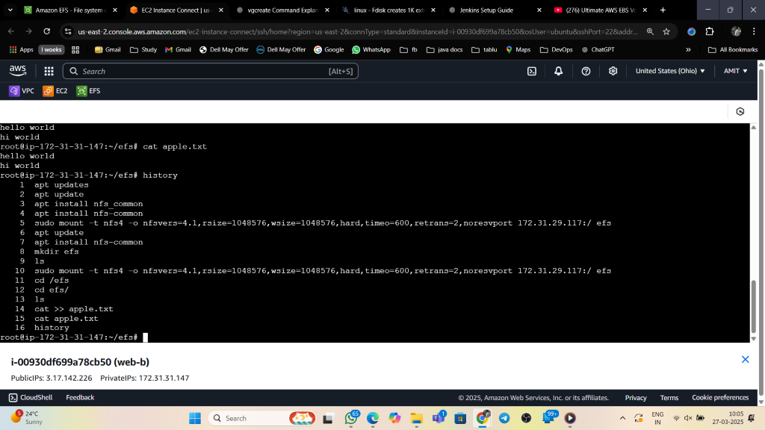

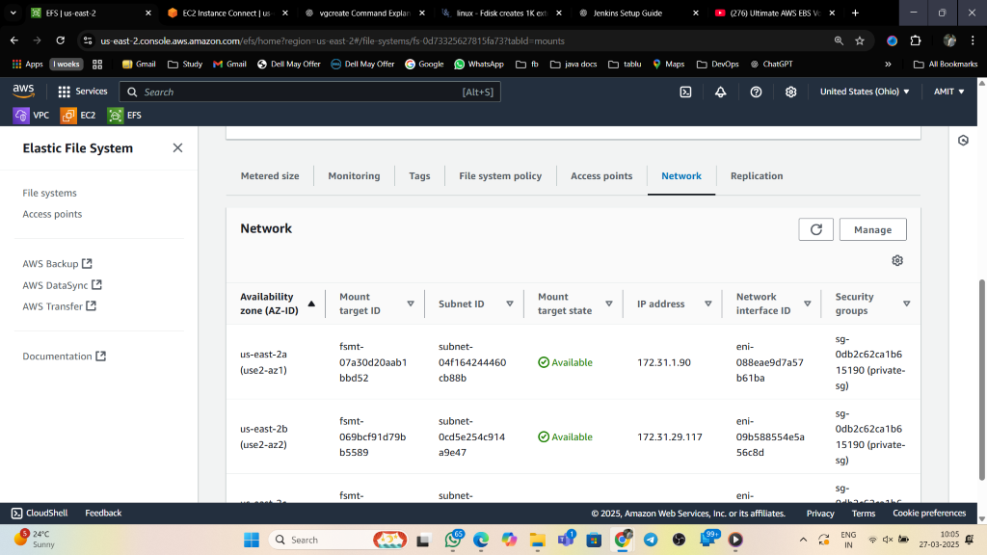

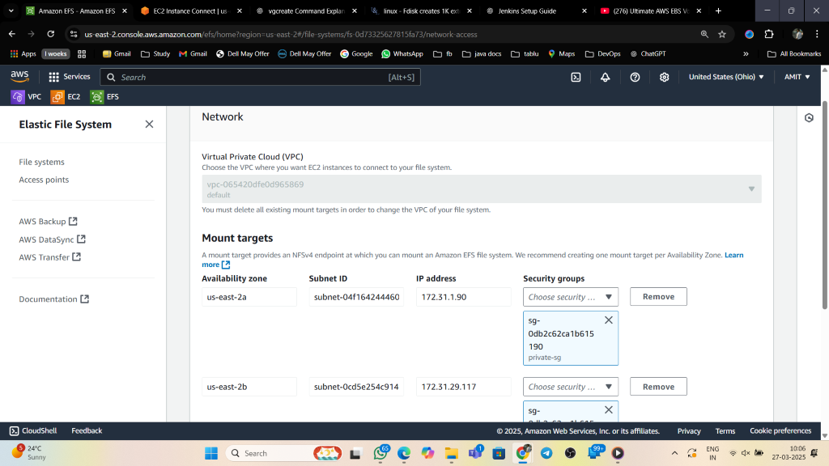

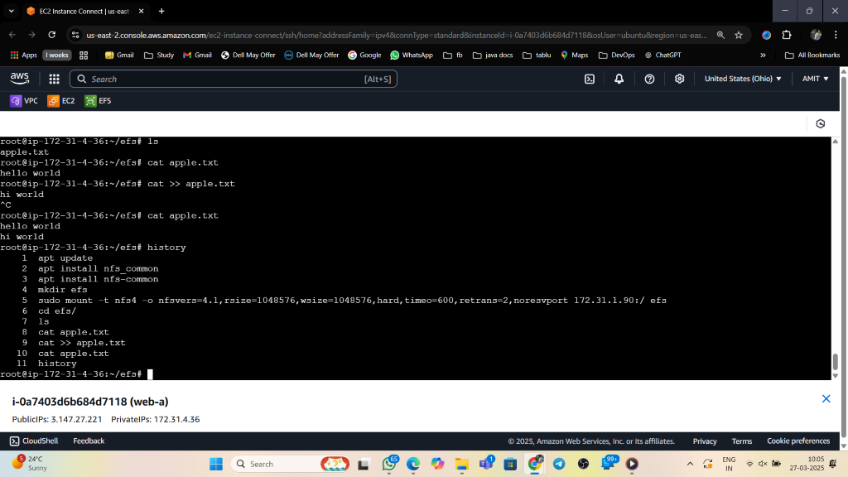

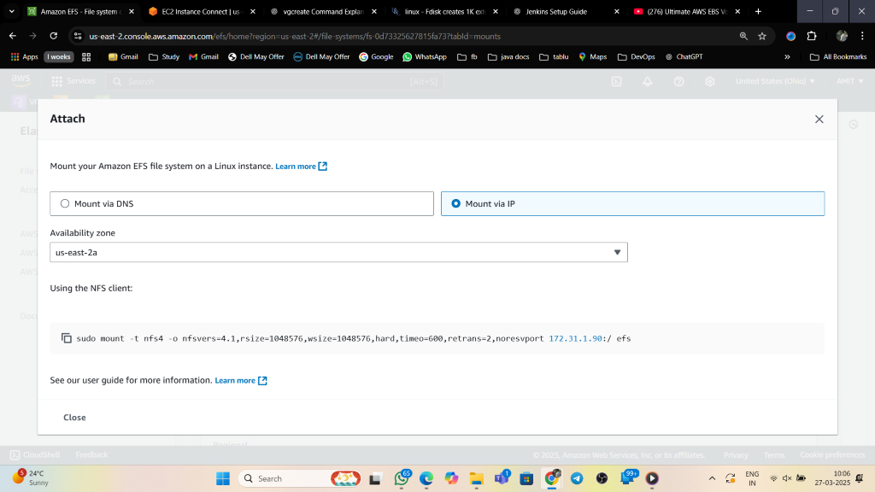

Here’s a quick summary (shorts) for setting up Amazon EFS:
Amazon EFS Quick Setup Steps:
- Create EFS File System:
- Go to AWS Console > EFS > Create File System.
- Choose your VPC, Availability Zone(s), and configure performance mode.
- Configure Security Groups:
- Ensure EC2's security group allows NFS (TCP 2049) traffic to/from the EFS security group.
- Install NFS on EC2 (Ubuntu Example):
sudo apt-get update
sudo apt-get install -y nfs-common
- Mount EFS:
- Create a directory:
sudo mkdir /mnt/efs
- Mount the EFS:
sudo mount -t nfs4 fs-xxxxxx.efs.us-west-2.amazonaws.com:/ /mnt/efs
- Make Mount Permanent (optional):
- Edit /etc/fstab:
sudo nano /etc/fstab
- Add:
fs-xxxxxx.efs.us-west-2.amazonaws.com:/ /mnt/efs nfs4 defaults,_netdev 0 0
- Test:
- Verify with df -h and check if the EFS is mounted.

This is a super-quick summary of the essential steps. Let me know if you'd like more details!
Here’s a short summary of Amazon EFS (Elastic File System):
- What is EFS?
EFS is a scalable, cloud-native file storage system that allows multiple EC2 instances to access the same data concurrently. It uses NFS and is fully managed by AWS.
- Key Features:
- Scalable and grows automatically.
- Shared access across multiple EC2 instances.
- High availability and durability.
- Supports General Purpose or Max I/O performance modes.
- Common Use Cases:
- Shared storage for web servers, applications, and databases.
- Data analytics and content management systems.
- How to Access:
- Install NFS client (nfs-common on Ubuntu).
- Mount using mount -t nfs4 <EFS_DNS_NAME>:/ /mnt/efs.
- Cost:
- Pay only for the storage used.
Let me know if you need more concise info or have any questions!

